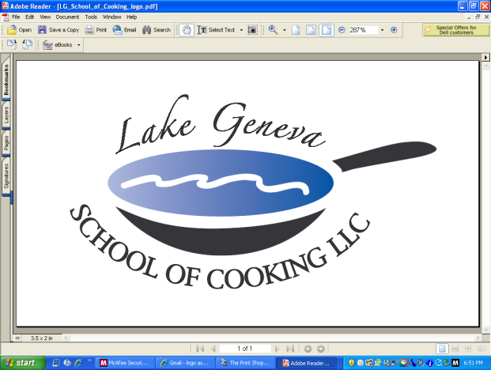

**Social Reception Team Building Event**

***“Social Reception Team Building Events & Good Food brings people together!”***

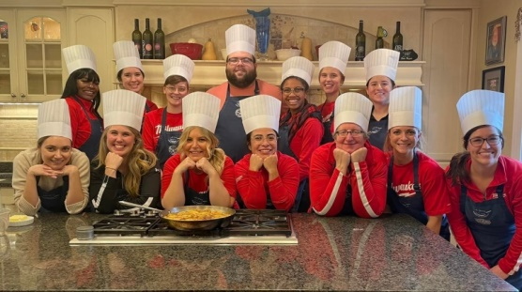

Spend a day with co-workers outside the office and head to Lake Geneva School of Cooking for a Customized

***Social Reception Team Building Event***!

Our “Hands-On” ***Social Reception Team Building Events*** create an environment promoting your company specific needs and goals though communication and cooperation among participants while recreating recipes from CHEF JOHN BOGAN

RECIPES FROM THE SEASONS OF MY LIFE cook book.

A typical **Social Reception Team Building Event** includes:

* Prior to the event: Chef gathers background information, meeting themes, buzzwords, and menu
* Upon arrival: introduced to your Chef and LGSC staff, toast with a sparkling wine and enjoy Hors d’oevres, and discuss the Team Event menu.
* Menu Prep: Your group is then broken into teams, each team receiving a recipe for their course, assigned a Chef Mate, a chef hat and an apron.
* Lessons: group lesson in basic techniques used in the preparation of the dishes, food and kitchen safety, and food and kitchen sanitation.
* Then the fun begins, as each team begins to prepare assigned menu item under the guidance of your Chef and Chef Mate.
* Let’s Eat!  The group will then join together for the Fine Dining portion of the event. Each team will elect a representative to Present their Social Reception creative dish to the Group.
* In addition, Chef is available in helping teams choose a wine to pair with their course as the group dines on each of the dishes.
* Total Event Time: approximately three (3-3 1/2) hours

Private “Hands-On” **Social Reception Team Building Event** Pricing:

**Private Facility Fee includes:**

The $400 private facility fee includes a Consultation with Chef John on business meeting agenda, choice of menu options, hands-on cooking class, coaching by your Chef and the LGSC staff, Sparkling Wine and Hors d’oeuvre Reception, non-alcoholic beverages, a tasting wine while cooking and a delicious Social Reception meal.

**Pricing:***Primary Package is $120 per participant*. The Primary Package includes a “Hands-On” class coached by your Chef and the LGSC staff, a Sparkling Wine and Hors d’oeuvre Reception, tasting wine and a delicious meal.

*Deluxe Package is $160 per participant*. The Deluxe Package includes all items in the Primary Package, plus a gift bag with a Lake Geneva School of Cooking apron, Chef John’s Signature Seasoning, and kitchenware.

*Cook Book Package is $180 per participant*. The Cook Book Package includes all items in the Primary Package, plus a signed copy of **CHEF JOHN BOGAN RECIPES FROM THE SEASONS OF MY LIFE** cook book and Chef John’s Signature Seasoning.

**How to Register & Payment Policy:**  
For more information on customizing and setting up your Social Reception Team Building event, please contact Chef/Owner/Author John Bogan, at 262-248-3933. Additional costs include: supplemental wine, a sales tax of 5.5% and a service charge of 20%. The Lake Geneva School of Cooking requires a 50% deposit, upon reserving the date for your event.  Accepting all major credit cards, the balance must be paid in full at conclusion of the event.

*\*LGSC prohibits outside alcoholic beverages.*