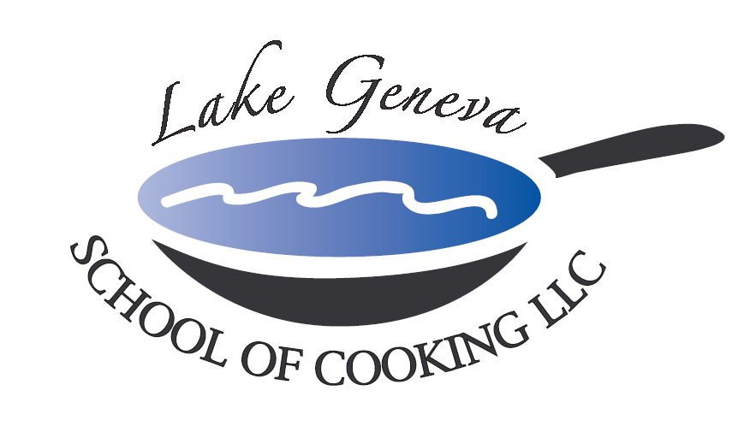

Bananas Foster

Serves 10
Ingredients:

½ cup (1 stick) butter
2 cups brown sugar
2 oz banana liqueur
10 bananas, quartered, lengthwise
2 oz dark rum
2 0z 151 rum
10 scoops vanilla ice cream
1 tsp cinnamon
2 Tbsp granulated sugar
1 Tbsp Orange Zest

Directions:
- Combine the butter, sugar, in a flambé pan or skillet. Place the pan over low heat on top of the stove and cook, stirring, until the brown sugar dissolves.
- Place the bananas in the pan. When the banana sections soften and begin to brown, carefully add the banana liqueur, dark rum and 151. Continue to cook the sauce until the rum is hot, then tip the pan slightly to ignite the rum.
- Mix cinnamon with granulated sugar and sprinkle cinnamon/sugar mixture over top of pan to create a dramatic sparkle effect. When the flames subside, lift the bananas out of the pan and place bananas over each portion of ice cream.
- Generously spoon warm sauce over the top of the ice cream and garnish with orange zest, serve immediately.

