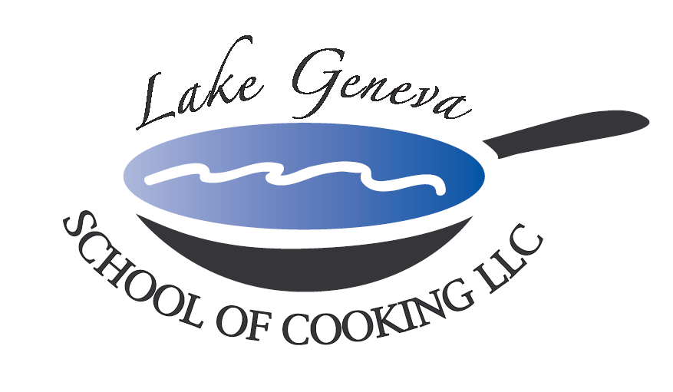

Pasta Shells Stuffed with Three Cheeses

Cloe’s Italian Sausage Gravy

Serves 12

Ingredients

2 Tbsp Salt
16 pieces jumbo pasta shells
1 1/2 pounds ricotta cheese or part skim ricotta cheese
1 cup mozzarella, grated
1/2 cup Parmigiano-Reggiano, grated
1/2 cup Asiago, grated
1/4 cup chopped flat-leaf parsley

Cloe’s Italian Sausage Gravy :
2 Tbsp extra-virgin olive oil,
2 pounds ground Italian Sausage
3 cloves garlic, chopped
2 small onion, finely chopped
1 cup red wine
2 cans (28 ounces) crushed tomatoes
1 Tbsp sugar
Chef John’s Seasoning
6 or 7 leaves fresh basil, chiffonade
3-4 sprigs fresh oregano

Preparation:
- Preheat oven to 350 degrees F.
- Bring a large pot of water to a boil. Salt water and add pasta. Cook shells 10 to 12 minutes, they should be softened but still undercooked at the center. Drain pasta and cool.
- Combine ricotta, 1/2 of the grated mozzarella, a couple of handfuls of Parmigiano and 1/2 of the Asiago. Add parsley to the cheeses and stir to combine.
- To a small saucepot over moderate heat add oil, brown Italian Sausage for 6- 8 minutes then add garlic and onions. Sauté for an additional 5-6 minutes. Deglaze with red wine, add tomatoes, sugar and season sauce with Chef John’s seasoning. Simmer sauce for 20 minutes and stir in basil and oregano leaves.
- Pour a little sauce into the bottom of a shallow medium sized casserole dish. Fill shells with rounded spoonfuls of cheese mixture and arrange them seam side down in casserole dish. Top shells with a slice of Italian Sausage and remaining sauce , mozzarella and Asiago cheeses. Place shells in hot oven and cook 12 to 15 minutes to melt cheeses and bubble sauce.

